SIMATS ENGINEERING (SAVEETHA SCHOOL OF ENGINEERING)
Department of Computer Science and Engineering ASSESSMENT TOOL 2 – Case Study Analysis

Course Code: | CSA65 | Course Title: | Generative AI and Large Language  Models
CO Assessed: | CO2 – Precision (BL1, BL2) | Assessment: | Assessment Tool 2 – Case Study Analysis
Weightage: | 20% of CIA | Total Marks: | 100 (1 Question)
CO1 Statement: | Apply prompt engineering techniques and utilize pre-trained Large Language Models through modern AI frameworks and APIs to solve real-world problems.(BL1, BL2)
Student Name: | C. Anu Keerthana | Reg. No.: | 192472057
Section / Batch: |  | Date:

Instructions to Students
- Answer any ONE questions. ● Total 100 marks
- Include architecture, explanation, suitable Python/API approach, advantages, limitations and evaluation. ● Time allotted: 30 mins

Code of Conduct
I _________C. Anu Keerthana(192472057)_________________ (Name / Reg No) certify that this submission is my original work and that I have adhered to the guidelines specified for this assessment. I understand that any violation of academic integrity rules will result in disciplinary action.
Signature of the Student: _________________________

SECTION A – Case Study Analysis

Q13. Case Study 13
Develop an appropriate solution for the given Generative AI/LLM scenario. Your answer should include analysis, justification, suitable model selection (GPT/BERT/RLHF/LoRA/PEFT where applicable), implementation approach, expected outcome, and limitations.
Topic: Legal document summarization

AI-Based Legal Document Summarization Using Large Language Models (LLMs)
A Case Study on Generative AI for Intelligent Legal Document Analysis

Abstract

The legal industry produces enormous volumes of documents every day, including contracts, court judgments, agreements, petitions, government notifications, and legal notices. These documents are often lengthy, highly technical, and written using complex legal terminology, making them difficult for legal professionals as well as the general public to understand. Manual review and summarization of legal documents is time-consuming, costly, and prone to human error.

Recent advancements in Generative Artificial Intelligence (Generative AI) and Large Language Models (LLMs) have transformed natural language understanding and generation. Models such as GPT, BERT, and Llama are capable of understanding complex language, extracting key information, and generating concise yet meaningful summaries. By integrating Retrieval-Augmented Generation (RAG), vector databases, and efficient fine-tuning techniques such as LoRA and PEFT, legal document summarization systems can produce highly accurate, context-aware, and trustworthy summaries while minimizing hallucinations.

This case study proposes an AI-powered legal document summarization system that uses GPT-based models together with BERT embeddings and Retrieval-Augmented Generation to automatically summarize legal documents. The proposed system significantly reduces reading time, improves accessibility, assists legal professionals in research, and enables non-experts to understand legal content more effectively. The report discusses the problem analysis, model selection, implementation methodology, expected outcomes, limitations, and future enhancements.

1. Introduction

Legal organizations generate millions of documents every year. These include contracts, agreements, employment policies, insurance documents, property deeds, court judgments, legal notices, wills, and government regulations. Such documents frequently exceed hundreds of pages and contain complex legal terminology that requires professional expertise to interpret.
Traditionally, lawyers and legal assistants manually read these documents to identify important clauses, obligations, deadlines, liabilities, and penalties. This process consumes a considerable amount of time and increases operational costs. Furthermore, manual summarization may overlook important information due to fatigue or human error.
Generative Artificial Intelligence has emerged as a revolutionary technology capable of understanding, analyzing, and generating human-like text.

Large Language Models such as GPT can comprehend long legal documents, identify essential information, and generate concise summaries while maintaining the original context. The proposed AI-based legal document summarization system aims to automate this process using advanced Natural Language Processing (NLP), transformer architectures, and Retrieval-Augmented Generation techniques.

2. Problem Analysis
Existing Challenges
The legal industry faces several challenges in processing legal documents.
- Legal documents are extremely lengthy.
- Complex legal terminology makes understanding difficult.
- Manual summarization is time-consuming.
- Reviewing multiple documents increases workload.
- Human errors may lead to missing important clauses.
- Legal professionals spend valuable time reading repetitive documents.
- Common citizens often cannot understand legal language.
These challenges reduce productivity and increase legal costs.

Objectives

The proposed system aims to:
- Automatically summarize legal documents.
- Preserve important legal meanings.
- Reduce document reading time.
- Extract critical clauses.
- Support question answering.
- Improve legal research efficiency.
- Provide summaries in simple language.

3. Existing System
Traditional legal document summarization mainly relies on manual review or conventional Natural Language Processing methods.
Common techniques include:
- Manual summarization
- Rule-based systems
- TF-IDF
- TextRank
- Keyword extraction
- Frequency-based summarization

Limitations:
- Poor contextual understanding
- Unable to understand legal relationships
- Limited scalability
- Low semantic understanding
- Cannot answer user questions
- Difficult to process very long documents
These methods often generate incomplete summaries because they focus on keywords rather than meaning.

4. Proposed System
The proposed system uses Generative AI to understand legal language instead of simply extracting sentences.
The workflow consists of:
- Upload legal document.
- Extract text from PDF or DOCX.
- Clean and preprocess text.
- Divide text into smaller chunks.
- Generate embeddings.
- Store embeddings in a vector database.
- Retrieve relevant information using semantic search.
- Generate summaries using GPT.
- Display summaries and answer legal questions.
This approach produces summaries that are accurate, readable, and context-aware.

5. Suitable Model Selection

Selecting the correct AI model is essential for obtaining high-quality summaries.
GPT (Generative Pre-trained Transformer)
GPT is selected as the primary language model because it has exceptional capabilities in understanding context and generating human-like language.
Advantages
- Excellent summarization
- Strong reasoning ability
- Understands legal terminology
- Produces fluent summaries
- Supports conversational question answering

BERT (Bidirectional Encoder Representations from Transformers)
BERT understands words based on both left and right context.
It is particularly useful for:
- Clause classification
- Named Entity Recognition
- Context understanding
- Semantic search
- Embedding generation

RLHF (Reinforcement Learning from Human Feedback)
RLHF improves response quality using feedback from human reviewers.
Benefits include:
- Safer responses
- Better factual accuracy
- Reduced hallucinations
- Human-friendly summaries

LoRA (Low-Rank Adaptation)
Instead of retraining billions of model parameters, LoRA updates only a small number of adapter parameters.
Advantages:
- Lower computational cost
- Faster fine-tuning
- Less GPU memory
- Suitable for legal-domain customization

PEFT (Parameter Efficient Fine Tuning)
PEFT allows fine-tuning only a small subset of parameters.
Benefits:
- Faster training
- Lower storage requirements
- Cost-effective deployment
- Easy domain adaptation

System Architecture

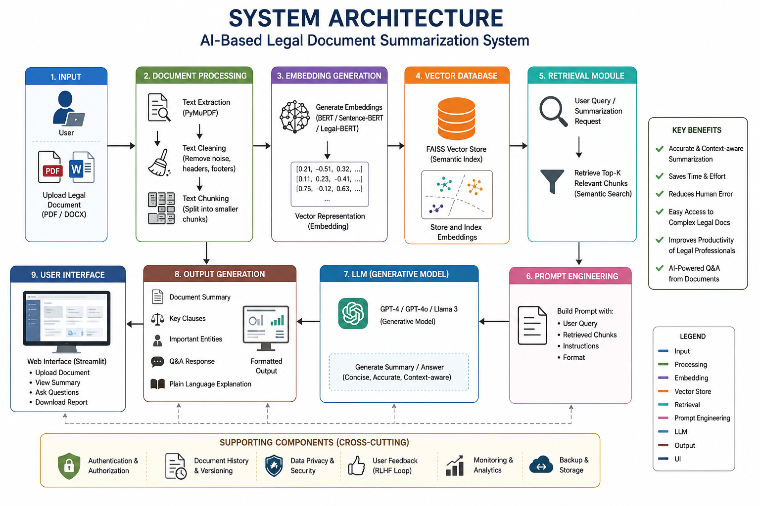

Key Features:

The proposed system offers several advanced features.
Intelligent Summarization
Produces concise summaries without losing legal meaning.
Clause Extraction
Extracts important clauses such as:
- Payment terms
- Liability
- Confidentiality
- Termination
- Arbitration
Named Entity Recognition
Detects:
- Person names
- Organizations
- Courts
- Dates
- Legal Acts
- Sections
Question Answering
Users can ask questions like:
"What is the termination clause?"
The AI answers directly from the uploaded document.
Multi-Level Summaries
The system generates:
- 50-word summary
- 100-word summary
- Detailed summary
Plain Language Explanation
Complex legal language is converted into easy-to-understand English.

Advanced Features:
Retrieval-Augmented Generation (RAG)
Instead of depending solely on the LLM's internal knowledge, the system retrieves relevant portions of the uploaded document before generating a summary.
Benefits include:
- Improved factual accuracy
- Reduced hallucinations
- Better context preservation
- More reliable legal summaries
Hybrid Search
The system combines:
- Dense vector search
- Keyword-based search (BM25)
This improves retrieval of important legal clauses.
Confidence Score
Each generated summary can include a confidence score based on retrieval relevance.
Explainable AI
The system can indicate which document sections contributed to each summary.

Limitations:

Although powerful, the proposed system has certain limitations.
- Hallucinations may occur if retrieval fails.
- OCR errors can affect scanned documents.
- Different countries have different legal systems.
- Human legal verification remains necessary.
- Fine-tuning requires quality legal datasets.

Future Enhancements:

Future improvements may include:
- Fine-tuning using Indian legal datasets.
- Multilingual legal summarization.
- Voice-based legal assistant.
- Mobile application support.
- Real-time court judgment analysis.
- Integration with legal databases.
- AI-powered legal risk prediction.

Real-World Applications
The proposed system can be used in:
- Law firms
- Courts
- Government departments
- Corporate legal teams
- Insurance companies
- Banking sector
- Educational institutions
- Legal research organizations

Conclusion

Legal document summarization is one of the most impactful applications of Generative AI in the legal domain. Traditional summarization methods often fail to understand legal context and relationships, whereas transformer-based Large Language Models provide a much deeper understanding of legal language. By combining GPT for text generation, BERT for contextual understanding, Retrieval-Augmented Generation for factual grounding, and efficient fine-tuning techniques such as LoRA and PEFT, the proposed system delivers accurate, context-aware, and user-friendly summaries.

The system has the potential to significantly reduce the workload of legal professionals, improve document accessibility for the general public, and accelerate legal research. Although challenges such as hallucinations and jurisdiction-specific legal differences remain, future advancements in AI, larger legal datasets, and improved fine-tuning methods are expected to make AI-powered legal assistants even more reliable. Overall, this solution demonstrates how Generative AI can transform legal document analysis into a faster, more efficient, and more accessible process.

RUBRICS FOR CALCULATION

Criteria | Wt. | Level 4 (Exemplary) | Level 3  (Proficient) | Level 2  (Developing) | Level 1  (Beginning)
Conceptual Depth | 30% | Deep, accurate understanding of  pre-training/fine-tuning/R  LHF concepts | Good  understanding with minor gaps | Superficial understanding of concepts | Misunderstands core concepts
Real-World Implications | 25% | Draws well-reasoned real-world implications and comparisons | Reasonable implications drawn | Weak or generic implications | No meaningful analysis presented
Analytical Rigor | 20% | Analysis is thorough, evidence-based, and well-structured | Mostly thorough analysis | Partial analysis with gaps in evidence | Superficial, unstructured analysis
Report Structure | 15% | Report/slides  professionally structured, easy to follow | Clear structure with minor issues | Structure unclear in places | Poorly structured submission
Citation &  Academic Writing | 10% | Properly cites sources; clear academic writing | Mostly cited, minor lapses | Inconsistent citation practice | No citation or referencing

Marks Evaluation:
Question No. | Conceptual Depth (30%) | Real-World  Implications (25%) | Analytical  Rigor  (20%) | Report Structure (15%) | Citation &  Academic  Writing (10%) | 100
Q1
 |  |  |  | Overall Total (100)

